Document Number: 130211JL-1

Originator: Jon Landau
Date: Feb 5, 2020

Data Sheet
PG1500-UPS Rev 1

Originator: / Sign:
Document Number: 130211JL-1
Approved By: / Sign:

Warning: This document may contain technical data whose export is restricted by the Arms Export Control Act (Title 22, U.S.C. Sec 2751, et seq.) or the Export Administration Act of 1979, as amended (Title 50, U.S.C., app. 2401 et seq.) Violators of these export laws are subject to sever criminal penalties.
Proprietary Data: The data disclosed in this document was originated in whole or in part by AJPS Inc. and is to be utilized only for the specific purposes for which it was supplied. It is not to be disclosed, transmitted or reproduced without the prior written consent of AJPS Inc.

SPECIFICATION | VALUE | UNITS
AC Output
Rated Voltage | 120 Pure Sine Wave (±5%) | Volts
Frequency | 60 (±0.25%) | Hertz
Rated Max. Current | 10 | Amps
Maximum Rated Power | 1500VA (0.8PF), 1200W (w/resistive load)
Phase | Single
Total Harmonic Distortion | <5 (w/resistive load) | %
Run Time on Battery | >10 (at 25°C, 80% Load, zero at or below 0C)  Note that at a 30W load battery time will be >800 minutes. | Minutes
Transfer Time to Battery | Instant, On-Line conversion, Internal Ac/Dc converter provides full power down to 85Vac input, below 85Vac input, internal batteries support the load. On-Line battery support enables high in-rush loads that internal Ac/Dc power supply cannot support.
AC Input
Voltage Range | 100 – 264 (phase to phase or phase to neutral) | Volts AC
Nominal Voltage | 115/230 | Volts AC
Frequency Range | 47 – 63, 100-264Vac, 393-407 115Vac | Hertz
Nominal Current | 14 @ 115V | Amps AC
Inrush Current (typical) | 50 | Amps AC
Power Factor (typical) | >0.98 @ 230VAC (full load)
Leakage Current | <3 @ 230VAC | mAmps AC
Efficiency (typical) | >80 @ 120VAC (Input to Output) | %
Conversion | Double
Battery
Rating | 48 | Vdc
Type | Lithium Iron Phosphate
Capacity | 5.7 | Ah
Hot-Swappable | Yes (when on AC Input)
Replacement Time | Less than one minute
Recharge Time | 5 Hours to 95% after full discharge
BXM Input
Voltage Range | 41 – 56 (Minimum Input Voltage Turn-ON ≥42VDC) | Vdc
Nominal Voltage | 48 | Vdc
Nominal Current | 60 | Adc
Inrush Current (typical) | 120@48V | Adc
Efficiency (typical) | >84 | %
Conversion | Single
SPECIFICATION | VALUE | UNITS
Front Panel Indicators
Battery Status | Green=Charged, Yellow=Charging, Red=Discharging
Switch LED | Green=Unit On
Front Panel Control
On/Off Switch | When on, enables UPS output
Alarm Disable | Enable/disable the audible alarm sounder
SNMP v1
 | AC Input present, BXM Input present, Battery Status (charged, charging, discharging), AC Output Active, Over Temperature
Rear Connectors
AC Output | 2 x NEMA 5-15/20R receptacles | J2
AC Input | IEC 320/C20 male receptacle | J1
AC Load Share* | Type MS3102E16-10S | J3
 | Pin A = Line, Pin B = Ground, Pin C = Neutral
Load Share Interface* | Female Sub-D 9 Pin | J4, J5
 | * Allows units to be stacked for increase in power handling capability, provides synchronization between units (not used in single UPS installation)
Ethernet | RJ-45, standard Ethernet pin out (SNMP communications) | J6
Emergency Cutoff | MS3102E12S3S, Pin A = +V, Pin B = -V  Contact closure  Open = output enabled, Closed via external switch = output disabled | J8
BXM Input | MS3102E20-23P, Pin A = +Vin, Pin B = -Vin (only used when PG-BXM is present) | J7
Safety Ground Stud | ¼ -20 Stud (Rear Panel)
Protection
Over Load | Yes
Output Short Circuit | Yes
Over Temperature | Yes
AC Input Protection | Yes
Isolation
AC Input to AC Output | Yes, Double
BXM Input to AC Output | Yes, Double
SPECIFICATION | VALUE | UNITS
Environmental
Operating Temperature Range | –20 to +50* | ⁰C
Storage Temperature Range | –40 to +65* | ⁰C
Working Humidity | 95 non-condensing* | %
Altitude | 10, 000 (Operating) Derate by 25% (900W) at 15,000  / 40,000 (Non-Operating)* | feet
Fungus | MIL-STD-810G, method 508*
Sand and Dust | MIL-STD-810G* (w/Optional Filters)
Vibration | MIL-STD-810G*
Functional Shock | MIL-STD-810G*
EMI
MIL-STD-461F | CE102, RE102*
 | * Designed to meet, lab testing required for formal certification
Physical Properties
Dimensions | 1.735H x 17.1W x 23D | inch
Mounting | 1U 19 Inch Rack (adjustable mounting depth)
Weight | 27 | lbs.
Material | Aluminum
Color/Finish | Gray

Output Enable Switch
Battery Module
Alarm Disable

Air Intake

PG1500-UPS
Front View

AC Output
AC Load Share
Air Exhaust

BXM Input
AC Input
Ethernet Port
Emer. Shutdown
Load Share Connectors
Ground Stud

PG1500-UPS
Rear View

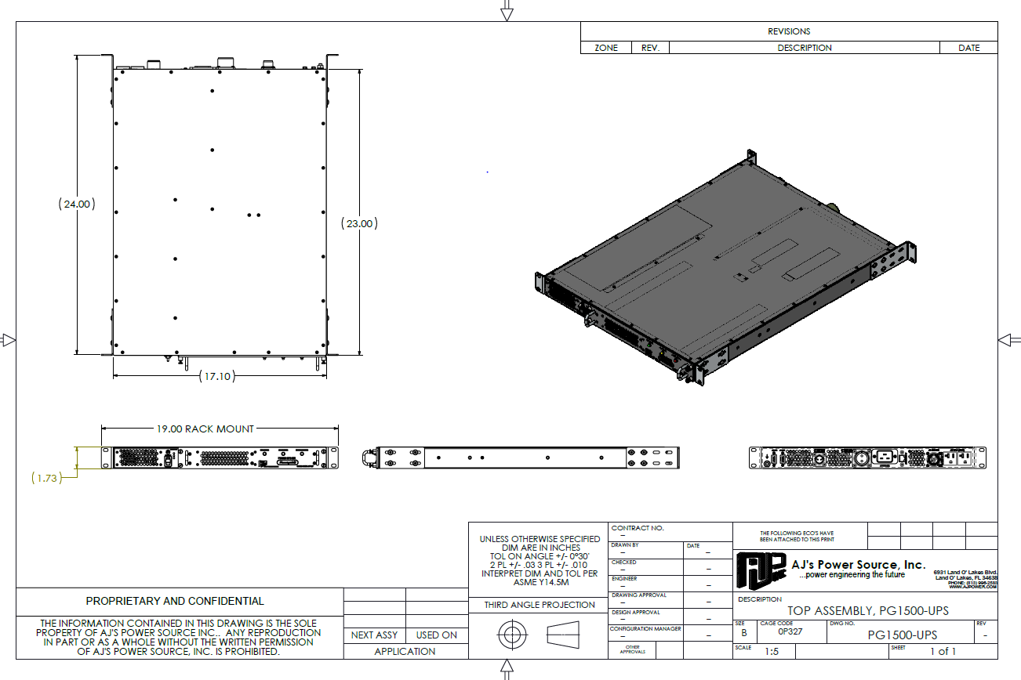

PG1500-UPS
Mechanical Drawing

